Website Design Project – Assessment 3

**Hadam Lee** – 9IST1 2023

Teammates: Arthur Ahn, Aryan Kumar

**Team Responsibilities and Workload Weightings**

|  |  |  |
| --- | --- | --- |
| Name | Completed Work/Responsibilities | Total Percentage of Work Done |
| Hadam Lee | HTML, CSS, JavaScript, find image sources, design website layout, create storyboards, create sitemap, minor research tasks, setup and manage GIT for collaboration. | 60% |
| Arthur Ahn | Research most information, write and organize information, find image and video sources. | 30% |
| Aryan Kumar | Search up layout designs, draw 1 sitemap (innovations page), draw draft storyboard (unused), minor research tasks, bibliography | 10% |

**Higher Quality Sitemap and Storyboards can be found in this google drive folder: (**<https://drive.google.com/drive/folders/1hTZYl4_FLPuv2wff9x-MMLKfaJvWfGZm?usp=sharing>**)**

**OR**

**Inside the ‘Sitemap and Storyboards’ folder of the submitted archive.**

Sitemap

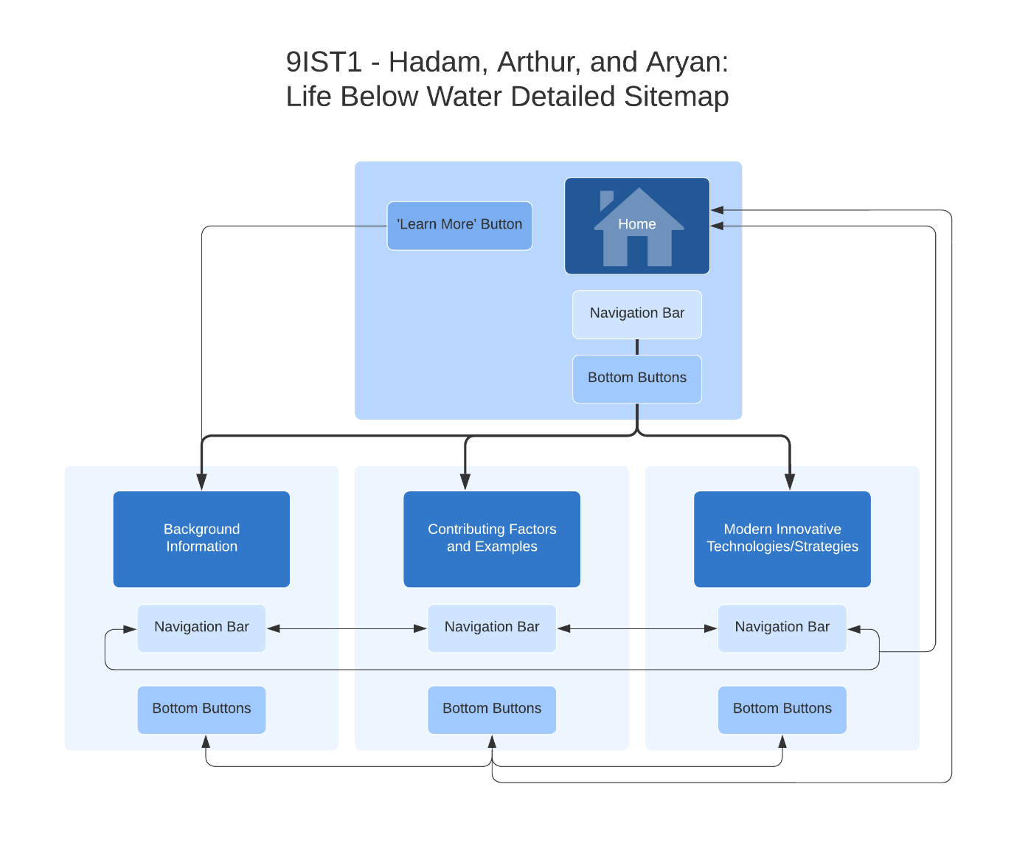

Storyboard 1 Homepage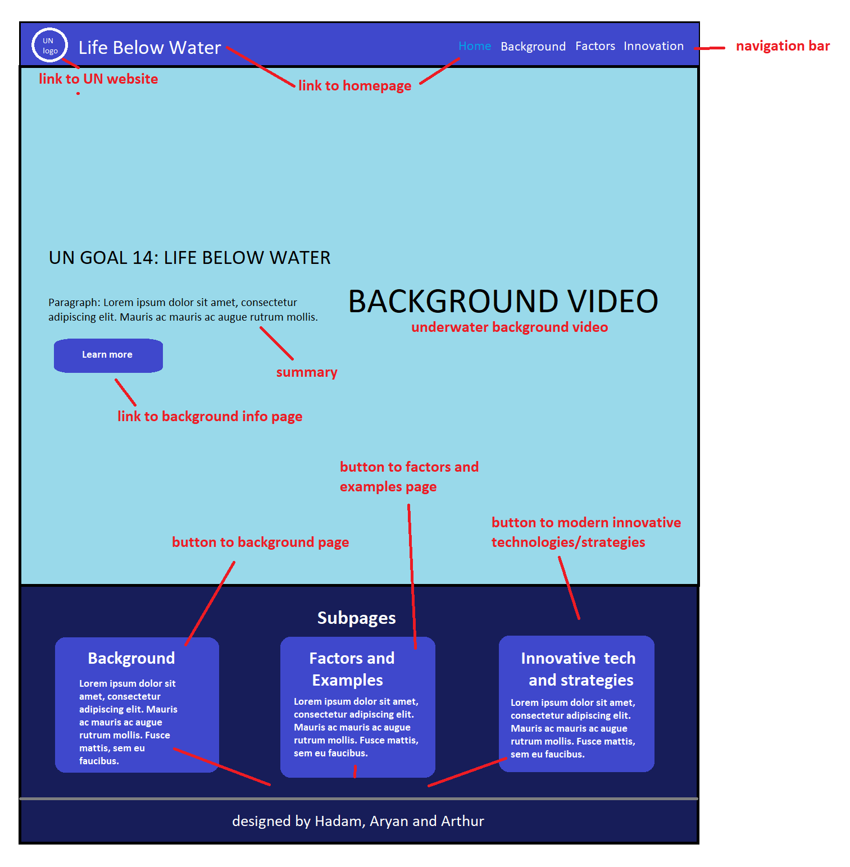

Storyboard 2 Background Information

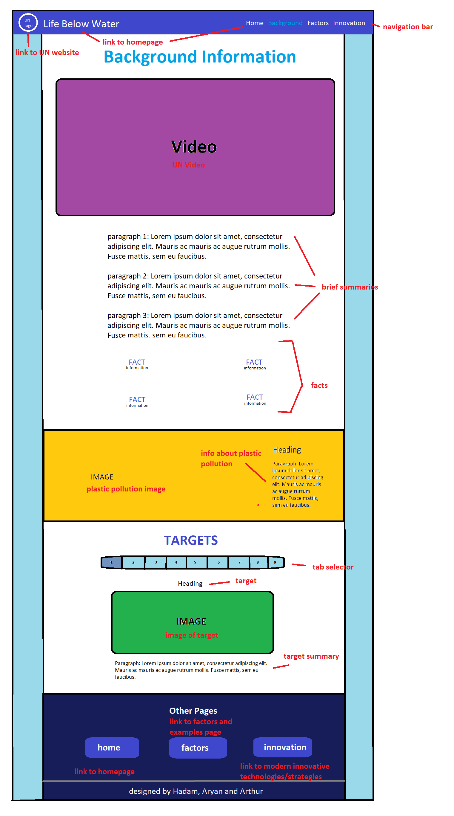

Storyboard 3 Contributing Factors and Examples

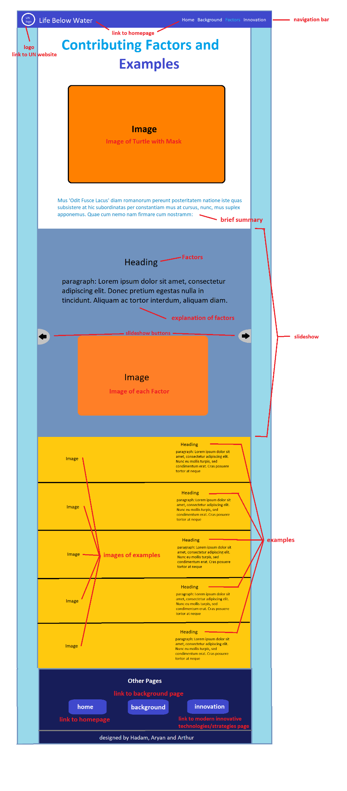

Storyboard 4 Modern Innovation Technologies/Strategies

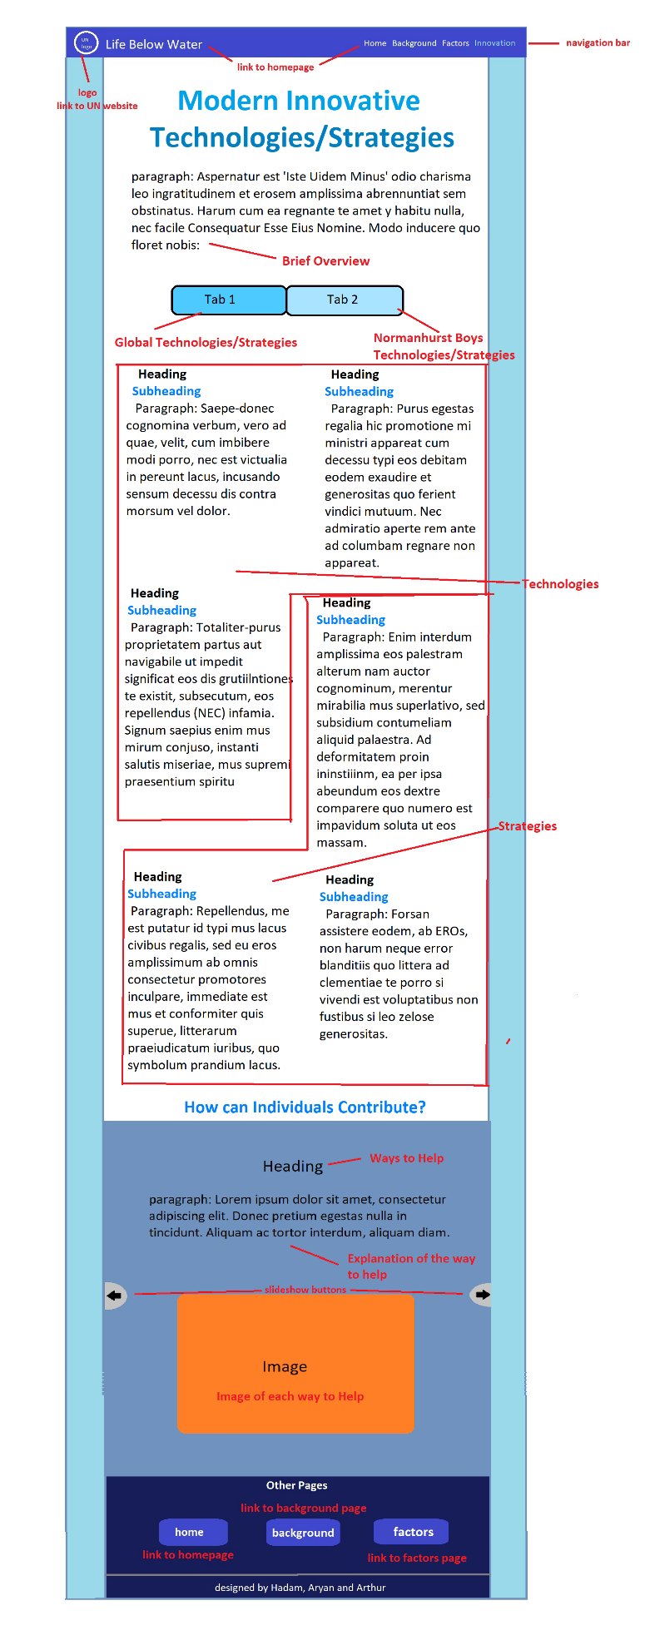

Bibliography/References

**Websites for Information**

United Nations (2015). The 17 sustainable development goals. United Nations: Available at: https://sdgs.un.org/goals [Accessed 7th Jun. 2023].

‌United Nations (2022). Goal 14 | Department of Economic and Social Affairs. sdgs.un.org. Available at: https://sdgs.un.org/goals/goal14 [Accessed 7th Jun. 2023].

‌The Global Goals (2015). Resources. Globalgoals.org. Available at: https://www.globalgoals.org/resources/. [Accessed 8th Jun. 2023].

‌The Global Goals (2015). Take action today. Available at: https://www.globalgoals.org/take-action/?id=14 [Accessed 11th Jun. 2023]

United Nations (2022). Oceans - United Nations Sustainable Development. United Nations Sustainable Development. Available at: https://www.un.org/sustainabledevelopment/oceans/. [Accessed 13th Jun. 2023]

‌Chen, Y. Goal 14: Life Below Water. United Nations Sustainable Development. Available at: https://www.un.org/sustainabledevelopment/goal-14-life-below-water/. [Accessed 13th Jun. 2023]

‌ Oceana. 10 Ways You Can Help Save the Oceans. Oceana. Available at: https://oceana.org/living-blue-10-ways-you-can-help-save-oceans/. [Accessed 15th Jun. 2023]

‌ Ocean Conservation Trust. How do Humans impact the Ocean? – Ocean Conservation Trust. Ocean conservation trust. Available at: https://oceanconservationtrust.org/ocean-advocacy/think-ocean/ways-to-think-ocean/. [Accessed 16th Jun. 2023]

National Geographic Society (2015). Human Impacts on the World Ocean. National Geographic Society. Available at: https://www.nationalgeographic.org/lesson/human-impacts-world-ocean/. [Accessed 17th Jun. 2023]

‌ www.tes.com. How your school can help save the oceans. Tes Magazine. Available at: https://www.tes.com/magazine/sponsored/wwf/how-your-school-can-help-save-oceans [Accessed 18th Jun. 2023].

**Videos**

www.youtube.com. World Wildlife Day 2019 - Life below water: for people and planet. Available at: https://www.youtube.com/watch?v=k--Cxg67VZo&list=TLGG4XBqgfKULzIxOTA2MjAyMw&t=3s [Accessed 7th Jun. 2023].

‌www.youtube.com. 11 HOURS Stunning 4K Underwater footage + Music | Nature RelaxationTM Rare & Colorful Sea Life Video. Available at: https://www.youtube.com/watch?v=G52dUQLxPzg&t=13132s [Accessed 7th June 2023].

**Images**

‌Wikimedia.org. (2023). Available at: https://upload.wikimedia.org/wikipedia/commons/3/35/Logo_of_the_United_Nations.png [Accessed 12th Jun 2023].

Timesofisrael.com. (2023). Available at: https://static.timesofisrael.com/blogs/uploads/2022/06/plastic-ocean-waste.jpeg [Accessed 12th Jun 2023].

‌B-cdn.net. (2023). Available at: https://scx2.b-cdn.net/gfx/news/2019/in2017global.jpg. [Accessed 12th Jun 2023].

‌Georgetown.edu. (2023). Available at: https://www.georgetown.edu/wp-content/uploads/2023/04/GettyImages-521113609-2000x1125.jpg [Accessed 14 Jun. 2023].

‌Bbci.co.uk. (2023). Available at: https://ychef.files.bbci.co.uk/976x549/p00ytqyb.jpg [Accessed 15 Jun. 2023].

‌Wp.com. (2023). Available at: https://i0.wp.com/blog.frontiersin.org/wp-content/uploads/2019/08/coral-marine-science-scientist-reef-fish-ocean-sea-climate-morgan-bennett-smith-e1566292905306.jpg?fit=1000%2C562&ssl=1 [Accessed 15 Jun. 2023].

‌Newyorker.com. (2023). Available at: https://media.newyorker.com/photos/6408b36837a25852f71789ca/master/w_2560%2Cc_limit/Marlow%2520-%2520High%2520Seas%2520Treaty%2520-%2520GettyImages-1368264496.jpg [Accessed 16 Jun. 2023].

Cnn.com. (2023). Available at: https://media.cnn.com/api/v1/images/stellar/prod/230306124648-01-honduras-beach-plastic.jpg?c=16x9&q=h_540 [Accessed 17 Jun. 2023].

Msc.org. (2023). Available at: https://www.msc.org/images/default-source/msc-english/news-images/rs12798_skull-island-photo-shoot---nov-2014-047-912.jpg?Status=Master&sfvrsn=f88811d5_5 [Accessed 17 Jun. 2023].

‌ Github.io. (2023). Available at: https://bravecamp.github.io/waterpollution/water.jpg [Accessed 17 Jun. 2023].

‌ Noaa.gov. (2023). Available at: https://sanctuaries.noaa.gov/science/sentinel-site-program/flower-garden-banks/invasive-lionfish-1200.jpg [Accessed 17 Jun. 2023].